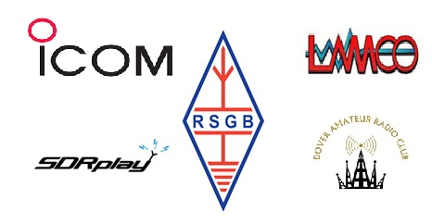

The Dover Amateur Radio Club

Spring Rally 2026

Join Us for an Unforgettable Spring Rally
Prepare yourself for an electrifying day at the Dover Amateur Radio Club Spring Rally, set to take place on 22 March 2026 at an exciting new venue—Eastry Village Hall. This year’s rally promises to be one of the most memorable yet, bringing together radio enthusiasts, exhibitors, and club members from across the region.

Exhibitors and Special Guests
The event will feature leading names in the amateur radio world. ICOM will be present, showcasing their new 7300 mk2 model, offering attendees a firsthand look at the latest technology. LAMCO and SDRPLAY, both renowned within the radio community, have also confirmed their attendance. Alongside these industry leaders, a fantastic selection of other exhibitors will be joining the line-up, ensuring there’s something for every enthusiast to discover.

Clubs and Societies Under One Roof
This year’s rally will not only represent the Dover Amateur Radio Club but will also welcome the Hilderstone Radio Society, East Kent Radio Society, and Folkestone Repeater Group. Having these respected organisations all in one place creates a unique opportunity for collaboration, knowledge sharing, and networking among radio amateurs of all levels.

Legendary Catering
No rally would be complete without great refreshments, and at this excellent venue, we have ensured that all attendees can enjoy a welcoming and comfortable dedicated seating area. Here, you’ll have the perfect opportunity to catch up with both old friends and new acquaintances, all while enjoying a delicious cup of tea or coffee. Our much-loved classic bacon roll will also be available, making it the ideal spot to relax and refuel during the day’s activities.

